|  |  |
| --- | --- |
| Team ID | PNT2022TMID13904 |
| Project Name | CONTAINMENT ZONE ALERTING |

DEPLOYMENT OF APP IN IBM CLOUD

UPLOAD IMAGE TO IBM CONTAINER REGISTRY

1. From your account dashboard, go to IBM Cloud Kubernetes Service.
2. From the left navigation menu, select Private Repositories.

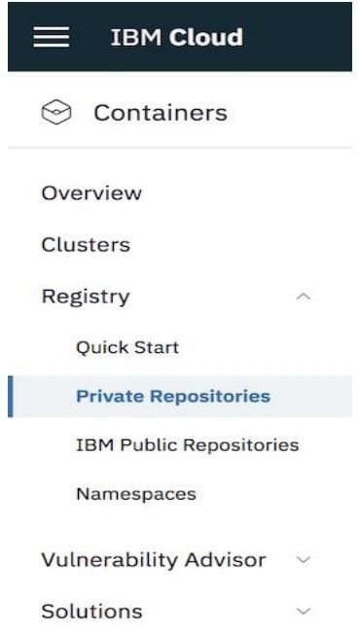

1. Install the Container Registry plug-in.

ibmcloud plugin install container-registry -r "IBM Cloud

1. Log in to your IBM Cloud account.

ibmcloud login -a <cloud_foundary_end_point_for_the_region>

1. Name and create your namespace. Use this namespace for the rest of the Ǫuick Start.

ibmcloud cr namespace-add <namespace>

1. Log your local Docker daemon into the IBM Cloud Container Registry.

ibmcloud cr login

1. Choose a repository and tag by which you can identify the image. docker tag g <image_name>

<region_url>/<namespace>/<image_name>:<tag>

1. Push the image.

docker push <region_url>/<namespace>/<image_name>:<tag>

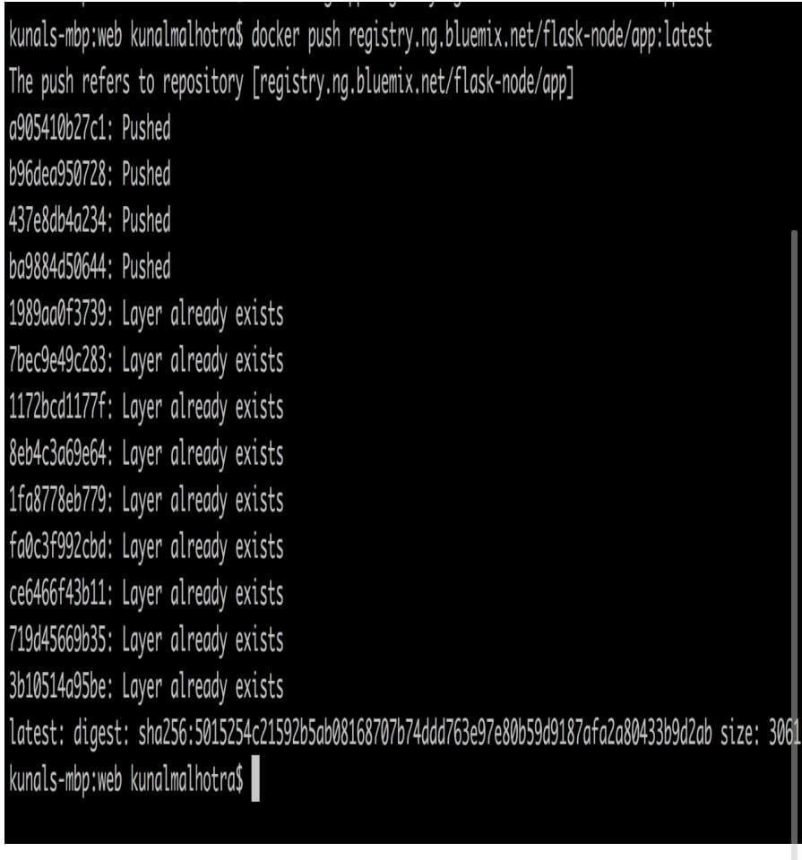

1. Verify that your image is in your private registry. ibmcloud cr image-list

